**ORM / Web Services Final Project**

**Topic: Article Post**

## **Instructor: LYPENGLEANG SEANG**

### **Group 6 members:**

* CHEA CHAN (Team Leader)
* CHEA DEVIT (Team Member)
* NEAM SINAT (Team Member)
* DANET THORNG (Team Member)
* CHANTHA ROEURN (Team Member)
* CHHUNHAK CHHOEURNG (Team Member)

1. **INTRODUCTION**

**Article Post** is very important for people's life currently, because it gains knowledge of everything like working, news, general knowledge, and technology.

Article post: is a website that can help the human to daily activities. This website helps people to find information easily.

**1.1 What is the project?**

The project is the Article Post, it provides the news and articles within Entertainment, Sports, Technologies, Ideas, Photo, Video and Socials news.

**1.2 Why did we choose this topic?**

We choose the project because we want all the people to get the new information and knowledge easier than watching TV, because they just use the pc or smartphone to access the platform and they can see all the information and it is also included in the entertainment news to make people happy.

**1.3 What is the purpose of this website?**

The purpose of this website is to turn visitors into prospects. And the way to do this is to identify the major user types visiting our site, speak to their needs and give them a clear action step to take next. It is a kind of helpful information to a specific user or audience so that the reader learns something new or understands a topic better. In future it will become a useful tool for its visitors.

**1.4 What are the benefits of this topic?**

There are many points that we see in a positive way. It is a part that can help such as:

* Grow general knowledge such as news, entertainment, technology, enhance idea,
* Growing your social media following
* Free online news
* Expand your personal network to users
* Stimulate to your reading skill to users
* Get useful feedback from the community
* Can sharing your personal content for marketing purposes

**1.5 What is our goal of making this happen?**

Our Goal: This website will provide the user the best experience well with the new information. Though it may be interesting or even entertaining, the foremost value of news is as a utility to empower the informed. The purpose of this website is thus to provide citizens with the information they need to make the best possible decisions about their lives, their communities,their societies, and their governments.

**1.6 How does my team build this platform?**

Basically, we are built this website from scratch with the web technology

First we start to defined this project and discuss with our team decide to choose the project and we all consider to choose Article post, and then we defined the project scope, and after that we start with the front-end technologies within HTML+CSS+JAVASCRIPT, Bootstrap, and then dividing the task to our team member,

For our backend project we see a lot of the technology, and we all know about the laravel framework and MySQL so we decided to choose this technology.

**1.7 Goals of the website:**

* Convert manual to computerized. Before this, All news lovers will go directly to a newspaper or magazine shop to buy it. It is a part of investing that is more expensive than, After that we want to make our news lover or news reader to make it easy. Then we found a solution that makes a website that has the important category for them and updates it everyday. After converting workload will be easy to manage data. By computerizing this website, it is easier to understand the journalist report which is hardly understandable with different and complicated handwriting.
* Improving step of visitor like sit finding news, better than hangout for looking news
* Save cost for reader examples like buying newspapers, magazines,..
* It is flexible and it is not time consuming or convenient
* Avoiding lose data information
* Up to date information by poster
* Sharing information as a category easy for viewer finding information
* To make it useful for all visitor
* Improving reading schedule to make good habit for visitor
* Can improve and help society by sharing information
* One more thing if system is more popular we engage with client for advertising for get income

**1.8 Benefits of the website:**

- Powerful, flexible, and easy to use

- Improver visitors satisfaction

- Reuse time for finding news, entertainment, sport...

- Simple and quick

- Users friendly

- Sharing news social media

**1.9 Here is our features:**

* Admin
* Login Page
* Register Page
* Logout
* Users
  + List users
  + Delete users
  + Update users
  + View user detail
* Category
  + List category
  + Delete category
  + Update category
  + View category
* Article
  + List Article
  + Delete Article
  + Update Article
  + View article
* User
* Home Page
* Entertainment Page
* Sport Page
* Social Page
* Technologies Page
* Article Detail
* Share to social media
* Amount Viewer
* Search Article

1. **TASK RESPONSIBILITY OF EACH MEMBER**

* **Team**:
* Analyst and Database Design: We discuss with each other how to design and explain about the process of our system to make sure everyone in the team understands the purpose of the system. Know what to do.
* We involved with coding together, sharing the task and help each other for fixing error
* **Chea Devit:**
* Database migration => Create database seeder => User admin, category and create faker data for article list & CRUD article
* After member push code, Devith will merge code and fixing the conflict file
* Add advertise to each list
* **Chea Chan**:
* Init project and push project to github
* Login & Register & CRUD users
* Search Article
* Divide task for each members
* Follow up
* Testing and feedback
* **Neam Sinat**:
* Footer of website
* Design articles & entertainment home page and fetch data from database to view
* Do slide presentation

* **Thorng Danet** :
* Design Social and Technology page and fetch data from database to view on page
* Design article detail
* Advertisements on article detail page
* Prepare Document Project Report
* Add document teacher’s project requirement needed
* **Roeurn Chantha**:
* Design Sport page and fetch data from database to the view
* Article list
* Advertisements on article list page
* Task responsibility
* **Chhunhak Chhoeurng**:
* Design Article detail
* Add pagination in each list
* Design front end
* Push project to the github
* Team meeting before finish
* Close project version 1.0.40

**III. SYSTEM MODULE BASE**

1. **Login page**

Amount of user must have username and password for login.

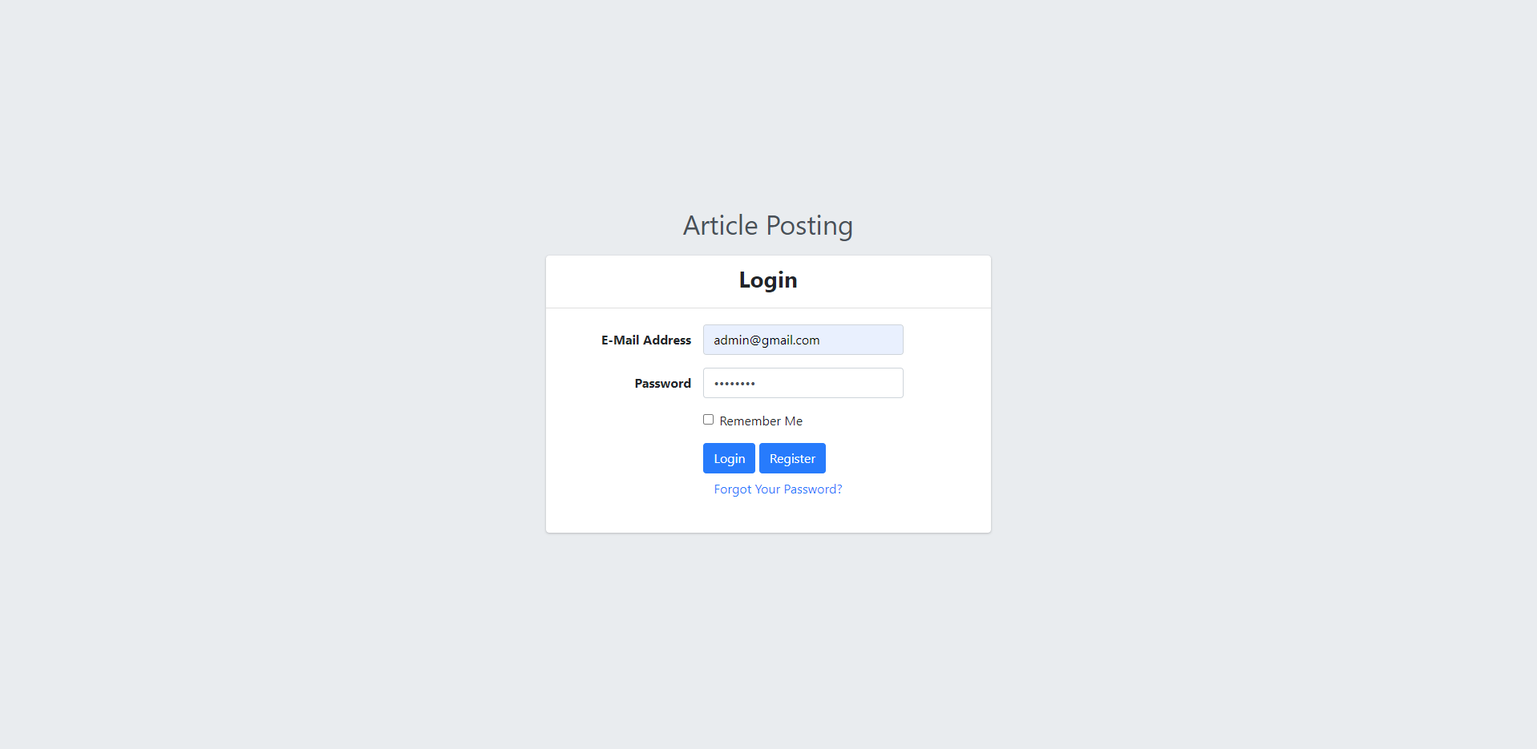

1. **Log Out page**

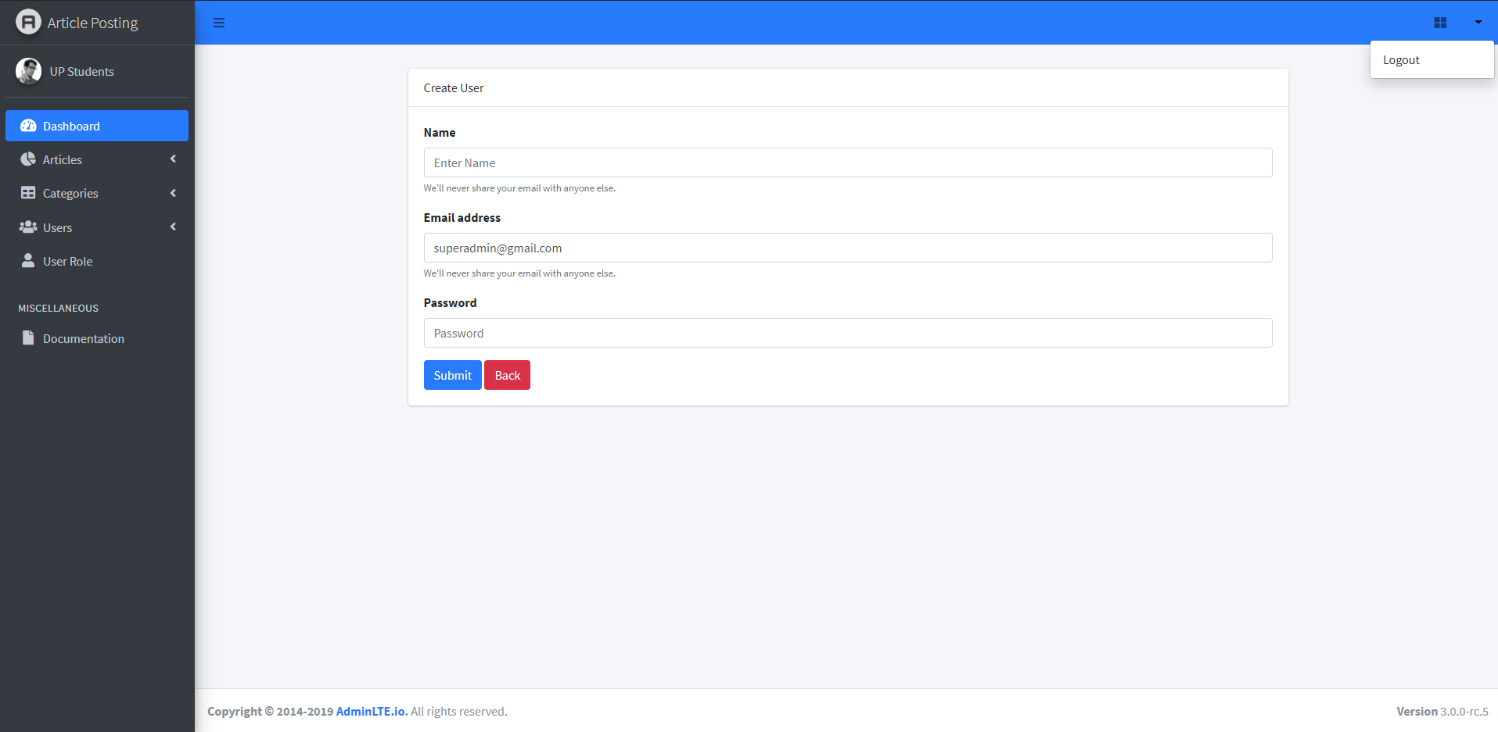

1. **Register for new user**

For new users we can register for request new user.

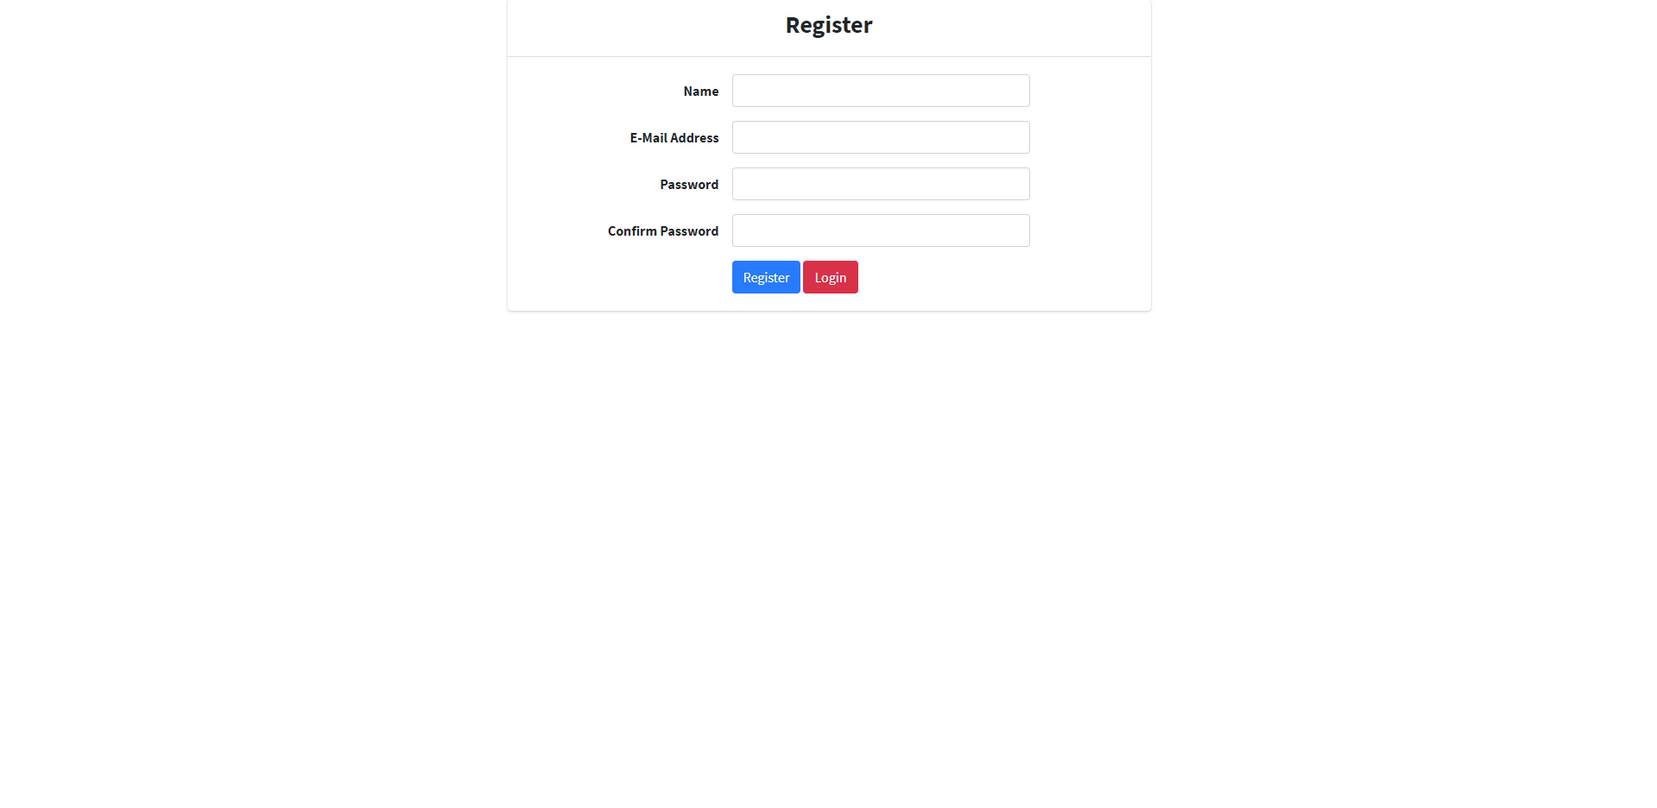

1. **User module**

This module is for system users and gives them permission to access the system. Through this module all user’s data will be kept and also can add a new user (Admin, normal user for posting article).

**4.1 User list:**

There are two types of users. One is the Admin of the website and another one is a normal user. Admin module can create normal users, add accounts, assign permissions, and more.

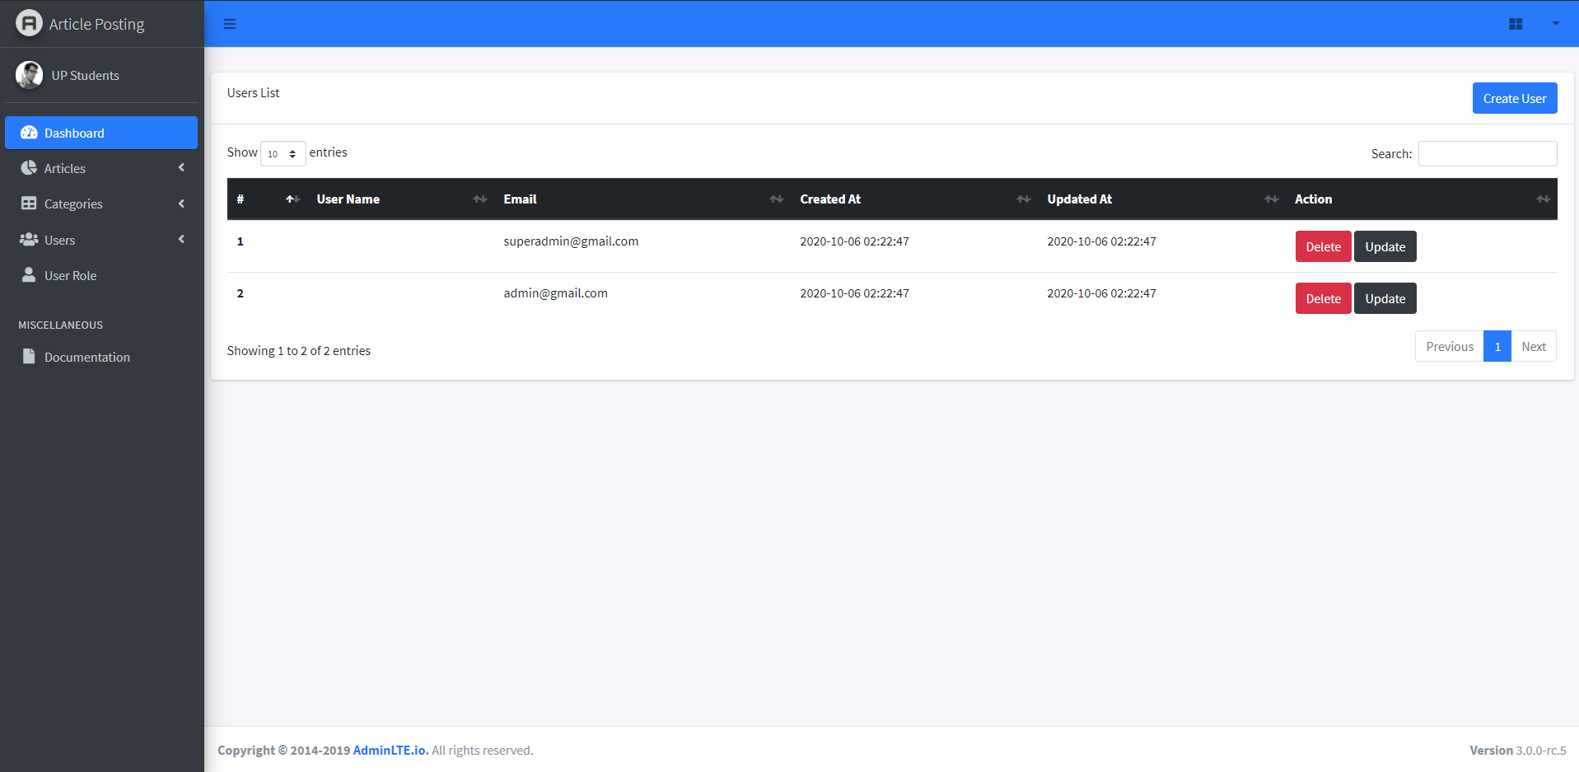

**4.2 Create a user account:**

It is the step for creating a new user for login the system. It is a necessary part in the system also that every website or system must have it indeed. We need to have a specific login user.

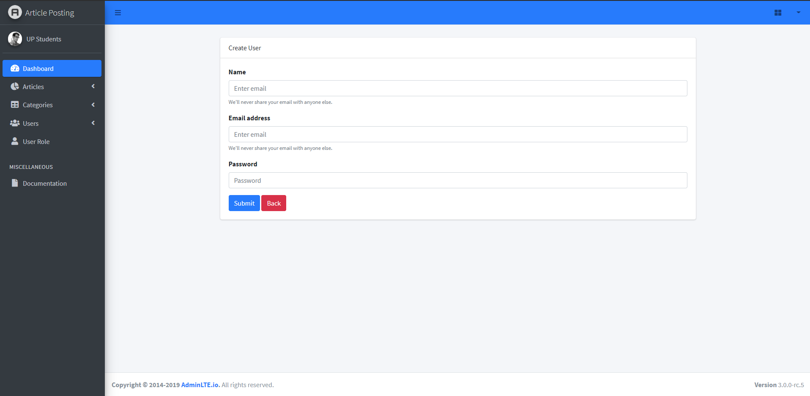

**4.3 User list**

After creating a user, our website will import user information to database.



**4.4 Update user**

Absolutely every website or system must have updated information that has been imported wrong. That’s why we cannot miss this module. We can update with anything wrong that we have done.

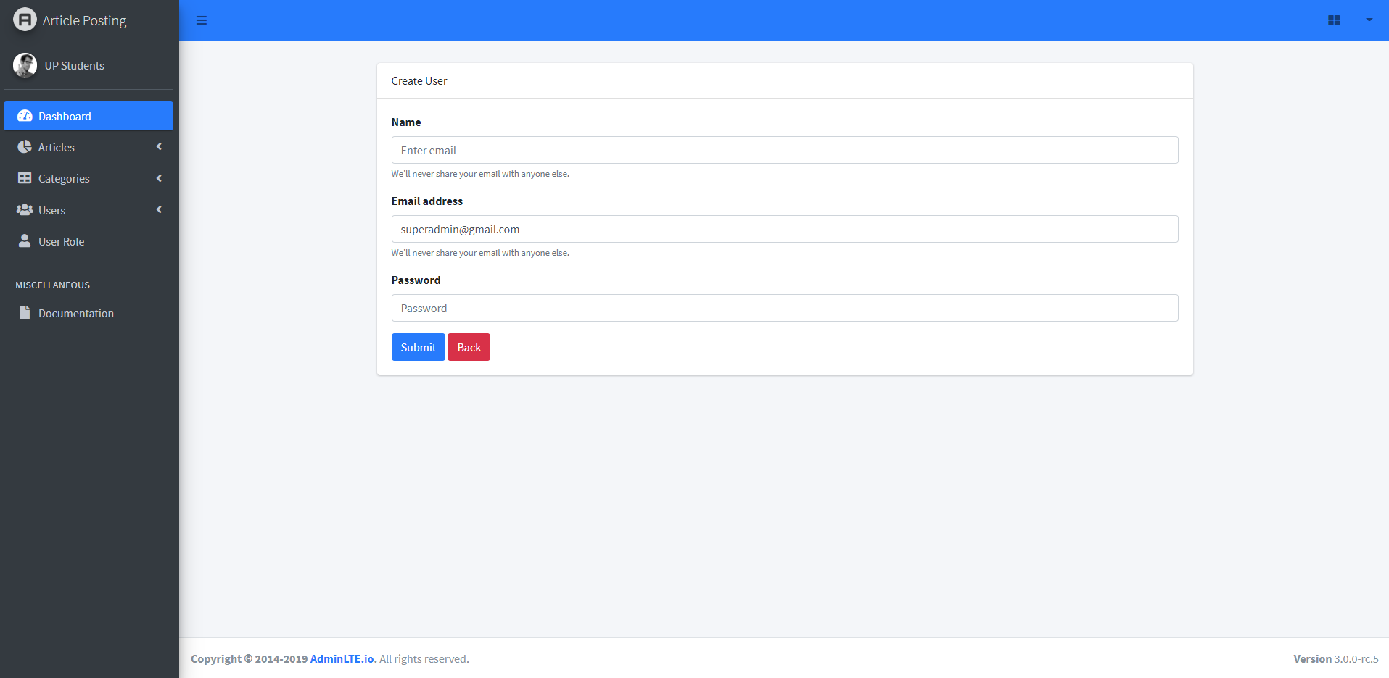

1. **Article post**

This module refers to all the posters in the backend post the content for each category everyday like sport,news, entertainment, beauty, technology something like this with the name of poster and date.

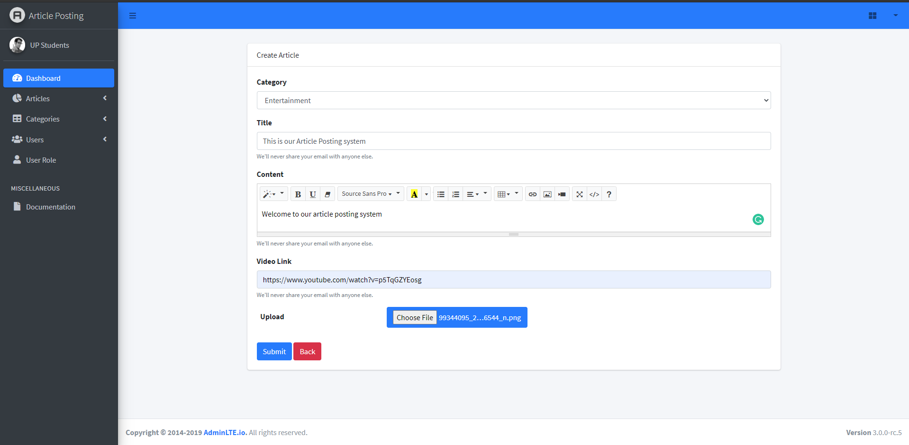

**5.1 Add article**



**5.2 Article List:**

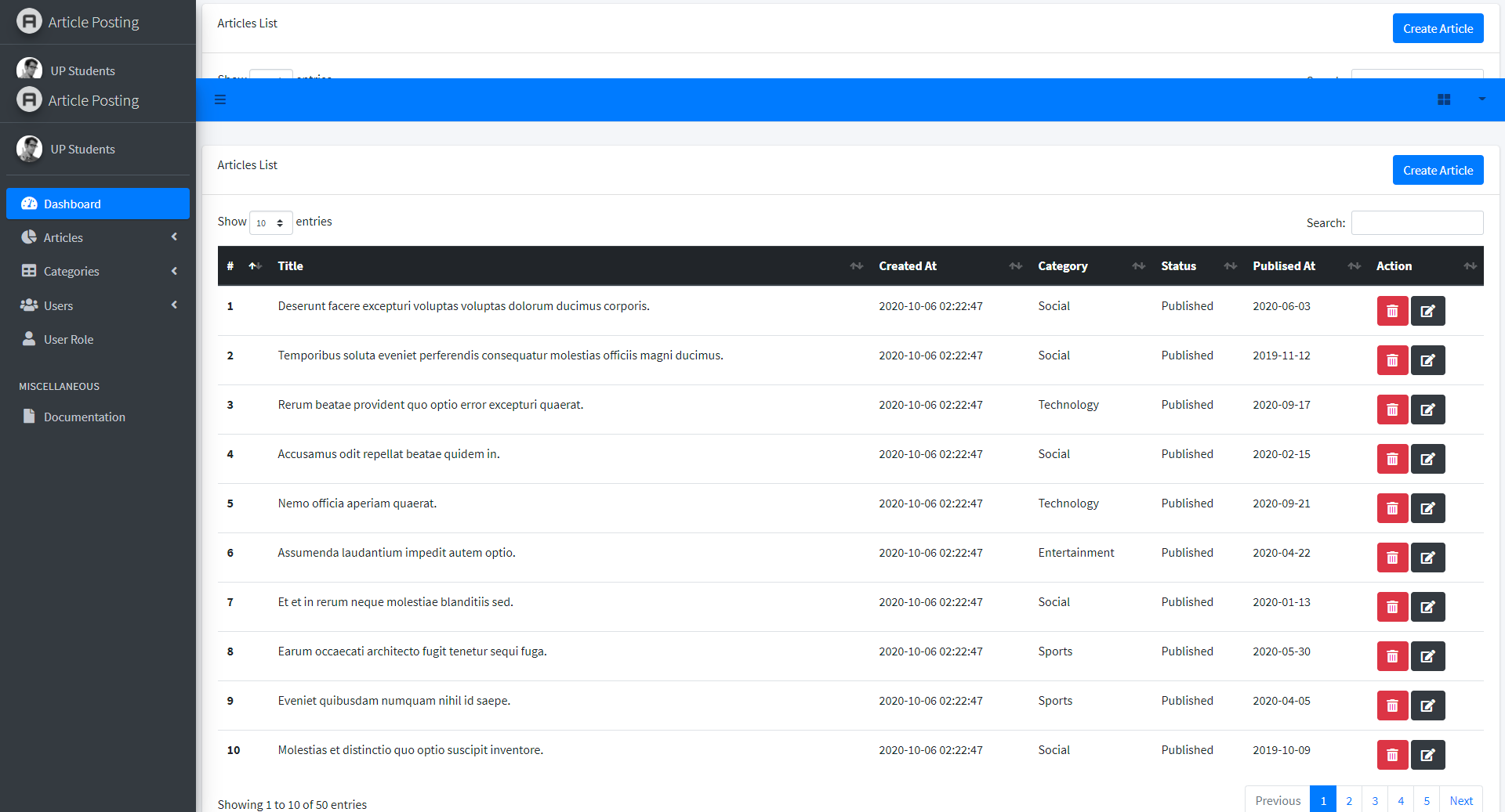

**5.3 Delete Article**

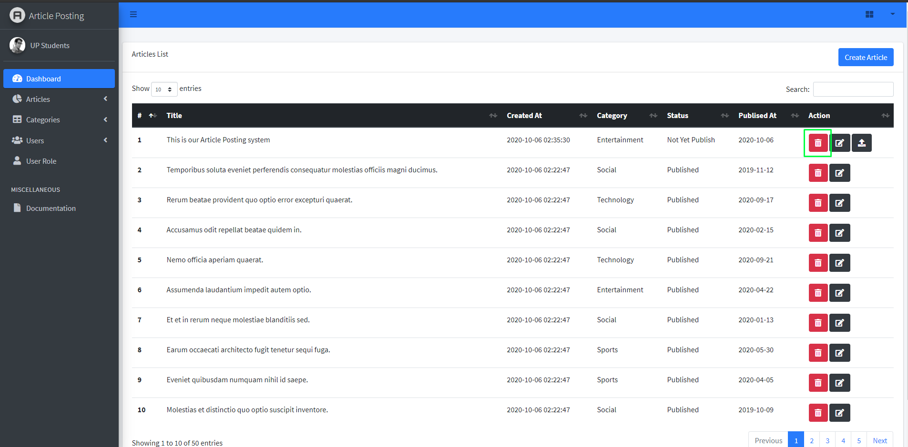

1. **Article detail**

After we post this article, the visitor wants to visit that article for more detail. Just click on that article then I will show everything in detail like paragraphs that describe it, image, and video if you have any.



**6.1 Publish article**

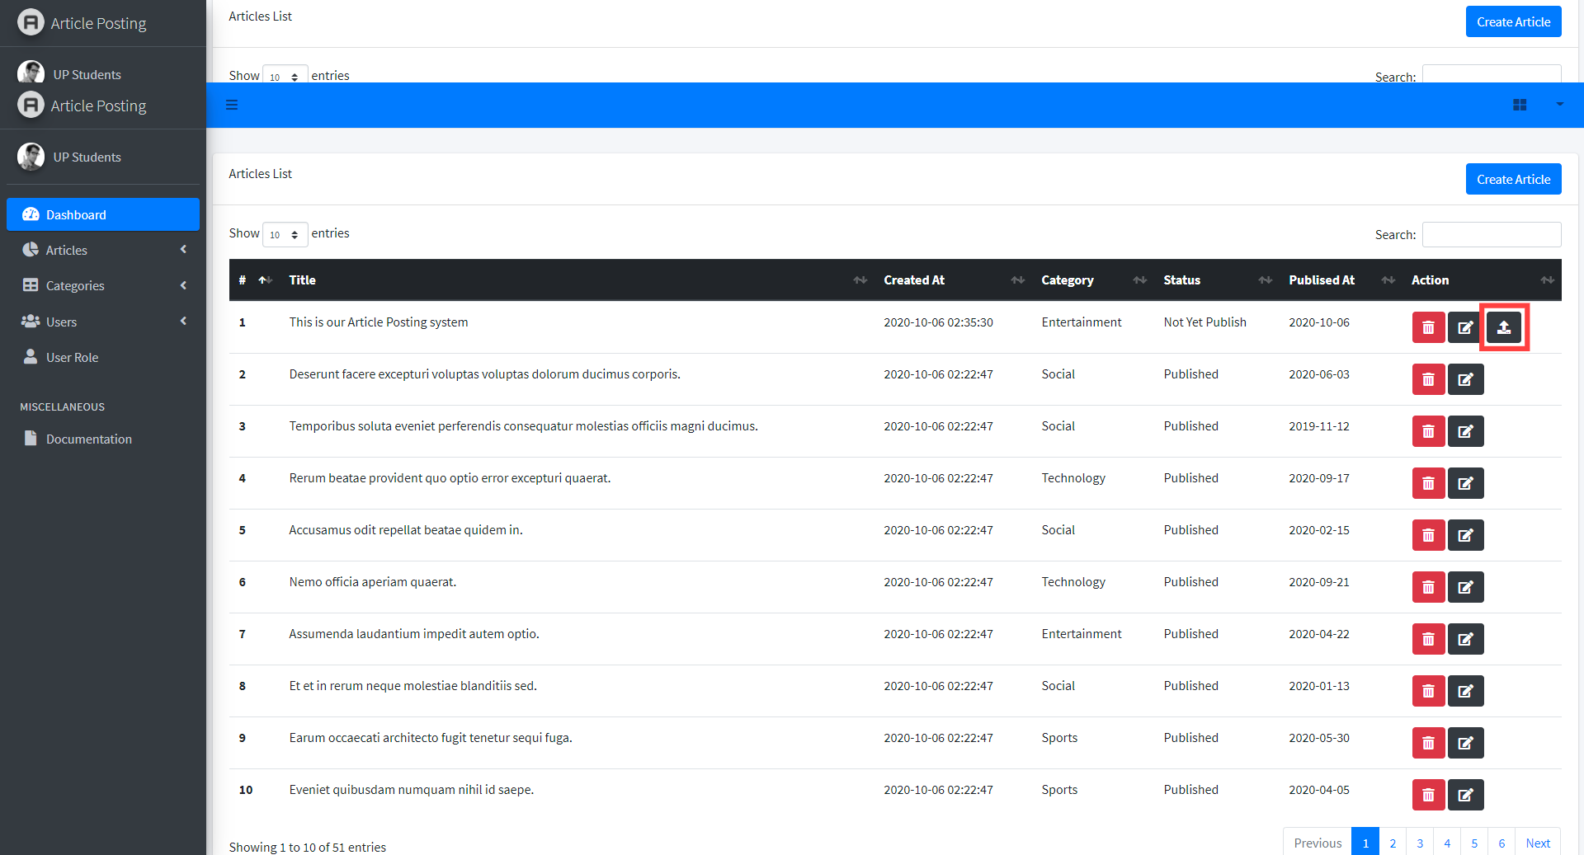

6.2 Publish list

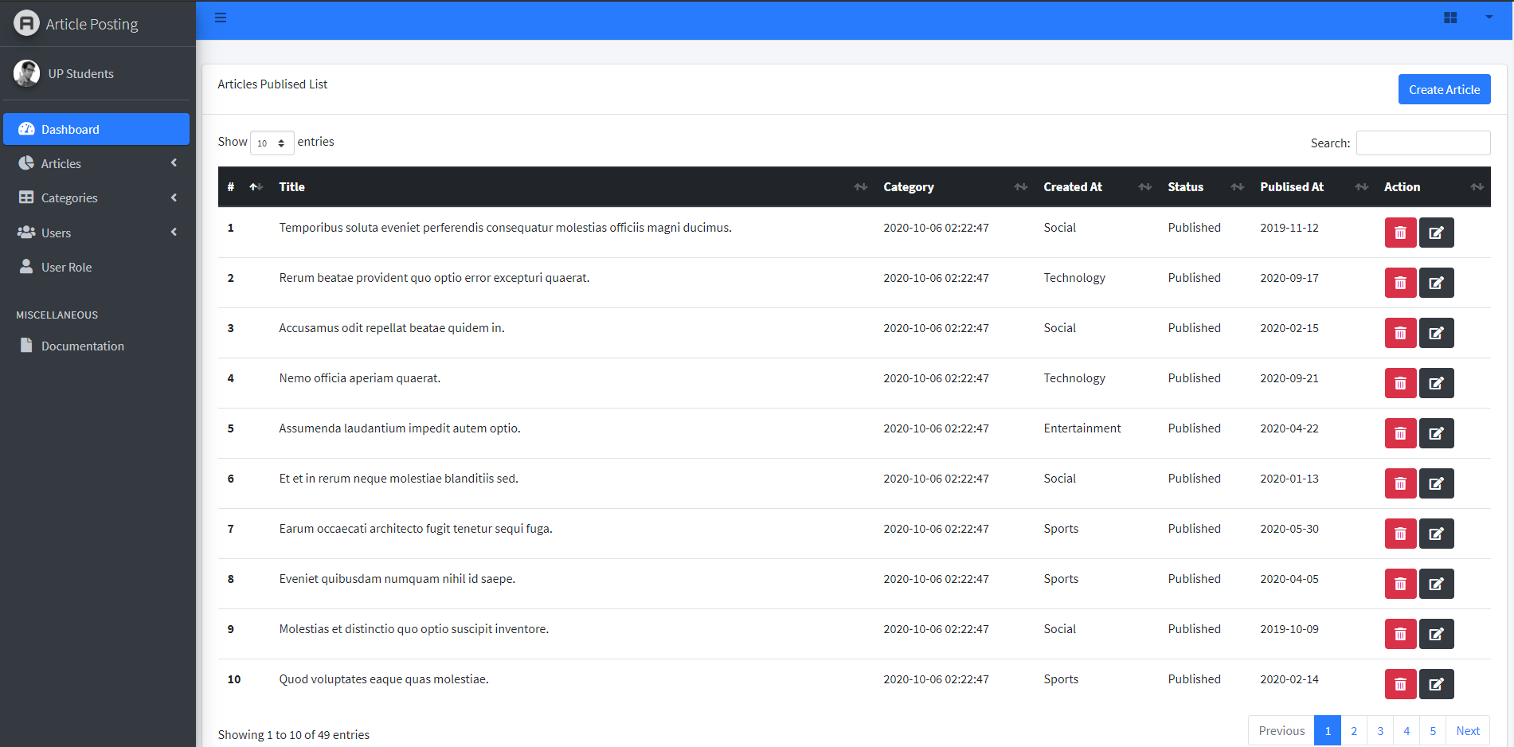

**6.2 Share to social media**

**On our website if you visitors want to share our website to social media. Visitors can share it easily by click on icons.**

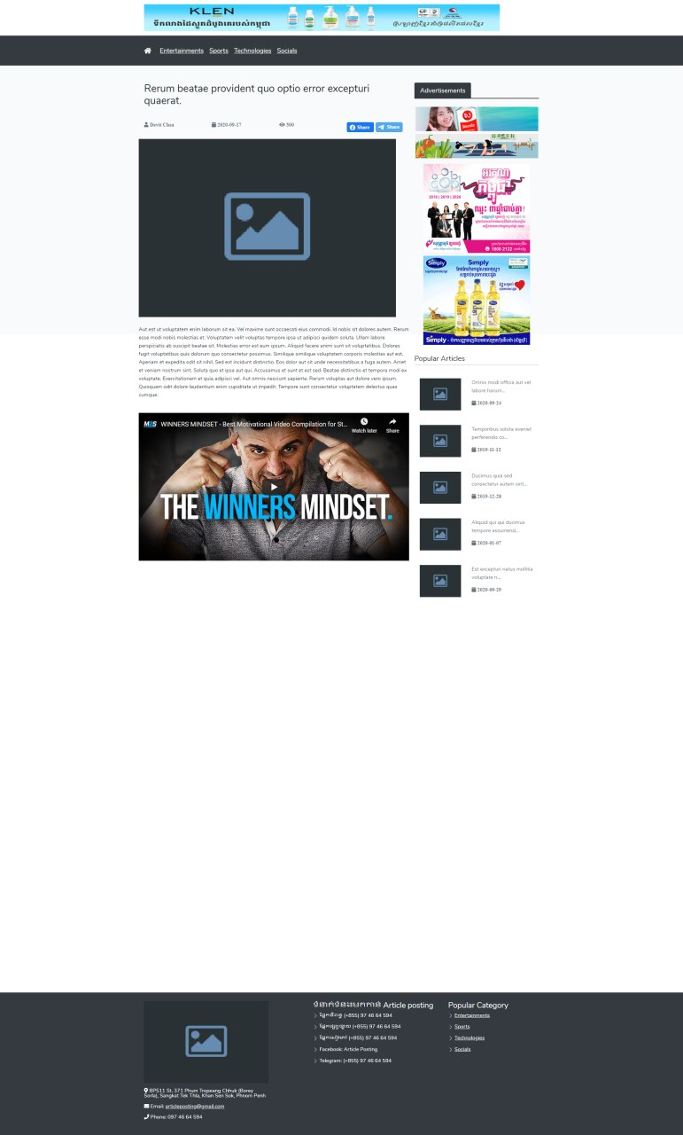



1. **Advertising**

Most websites always have advertisements to promote their products and services. So this feature is really important too. To make our website colorful and attractive. One more thing it is a part of income also. Advertising is a means of communication with the users of a product or service. Advertisements are messages paid for by those who send them and are intended to inform or influence people who receive them, as defined by the Advertising Association.

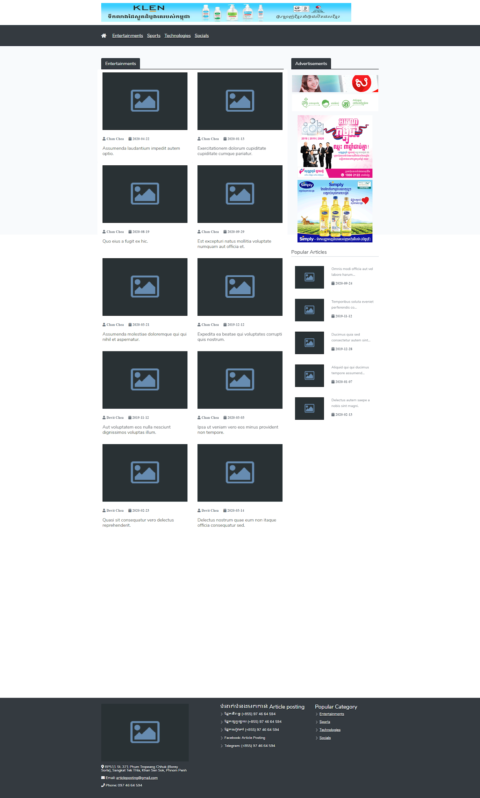

1. **Loop menu**

Category is a group of individual web pages together based on similar subject or theme. It gives order and structure to a website’s content, or its taxonomy.

**8.1 Sport Page**

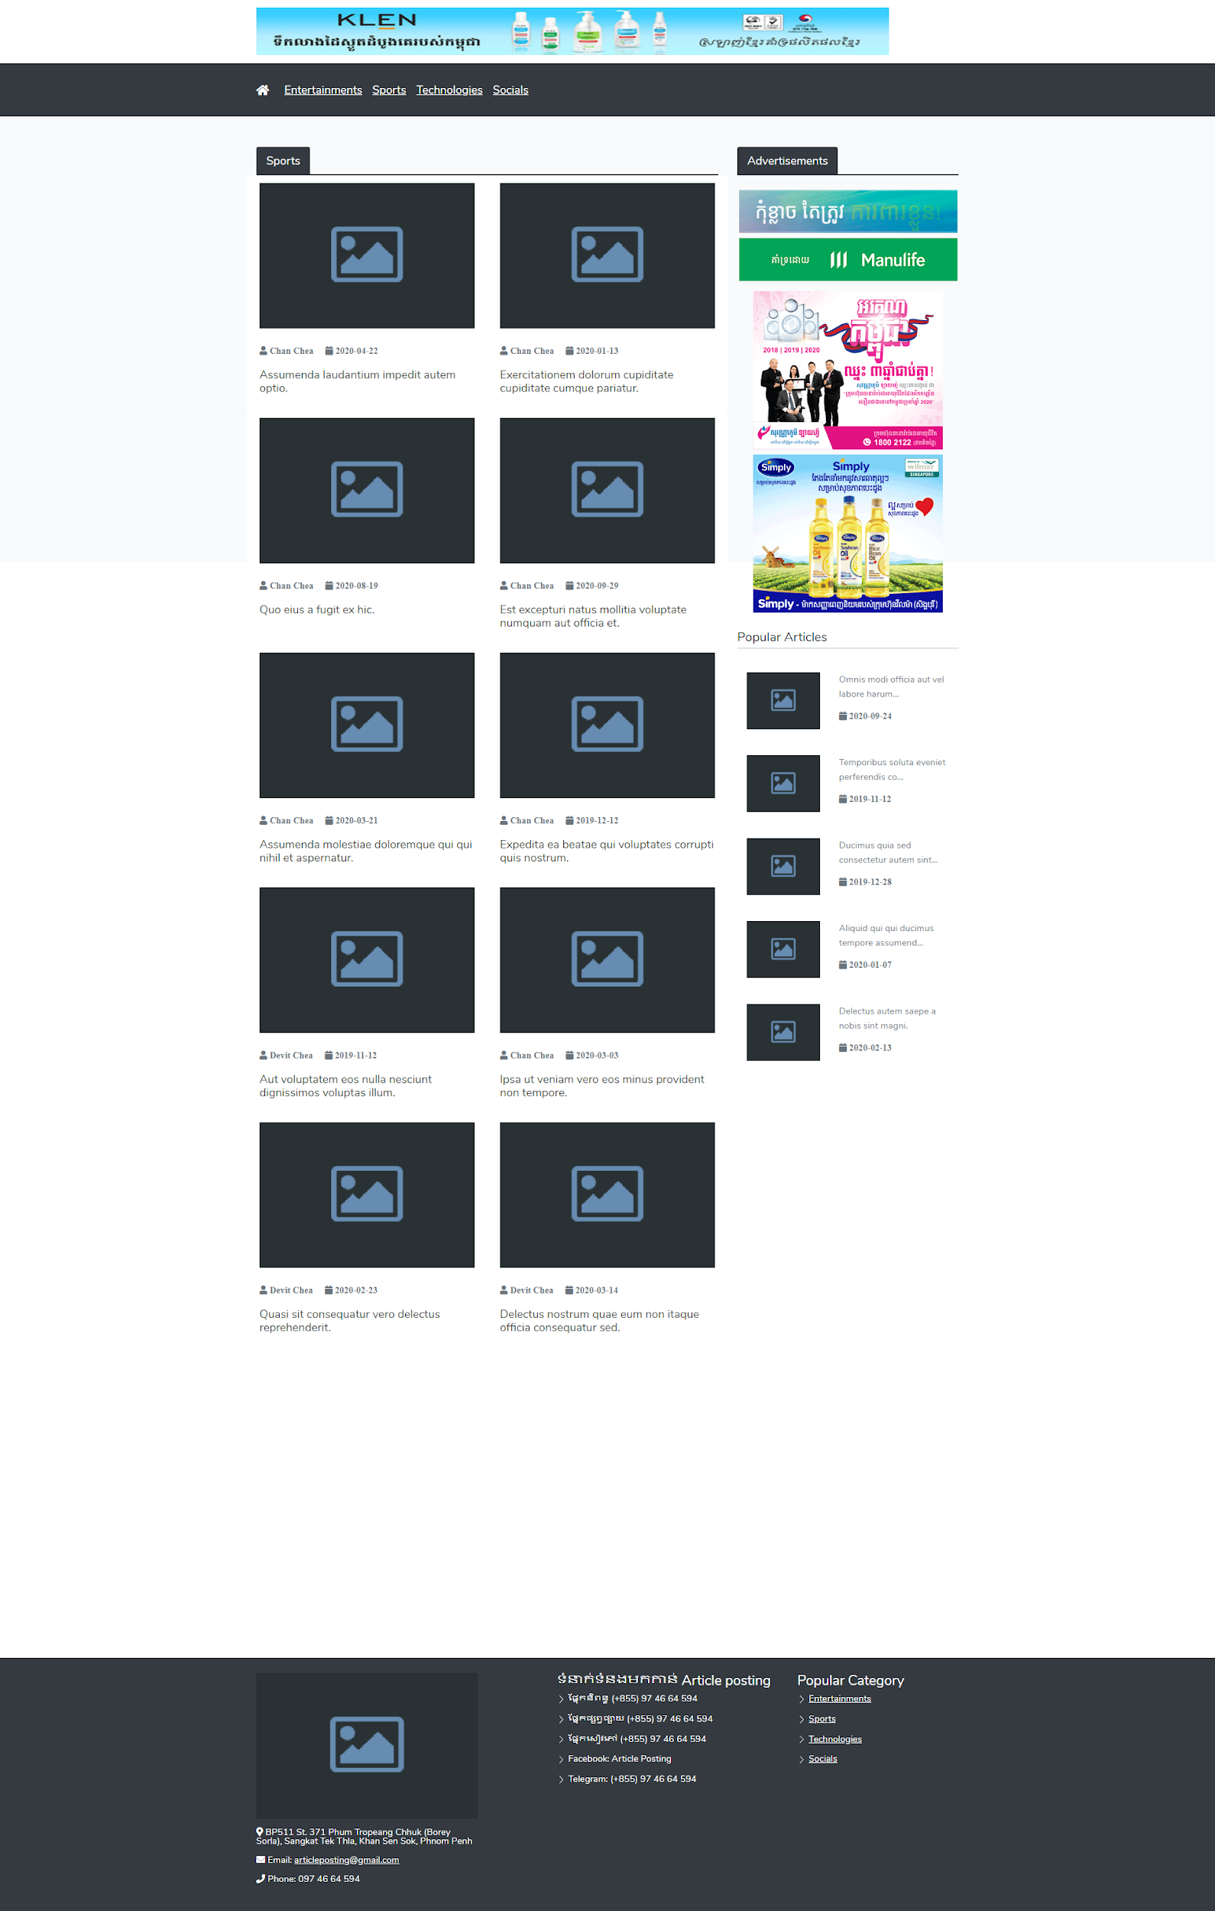

**8.2 Technology page**

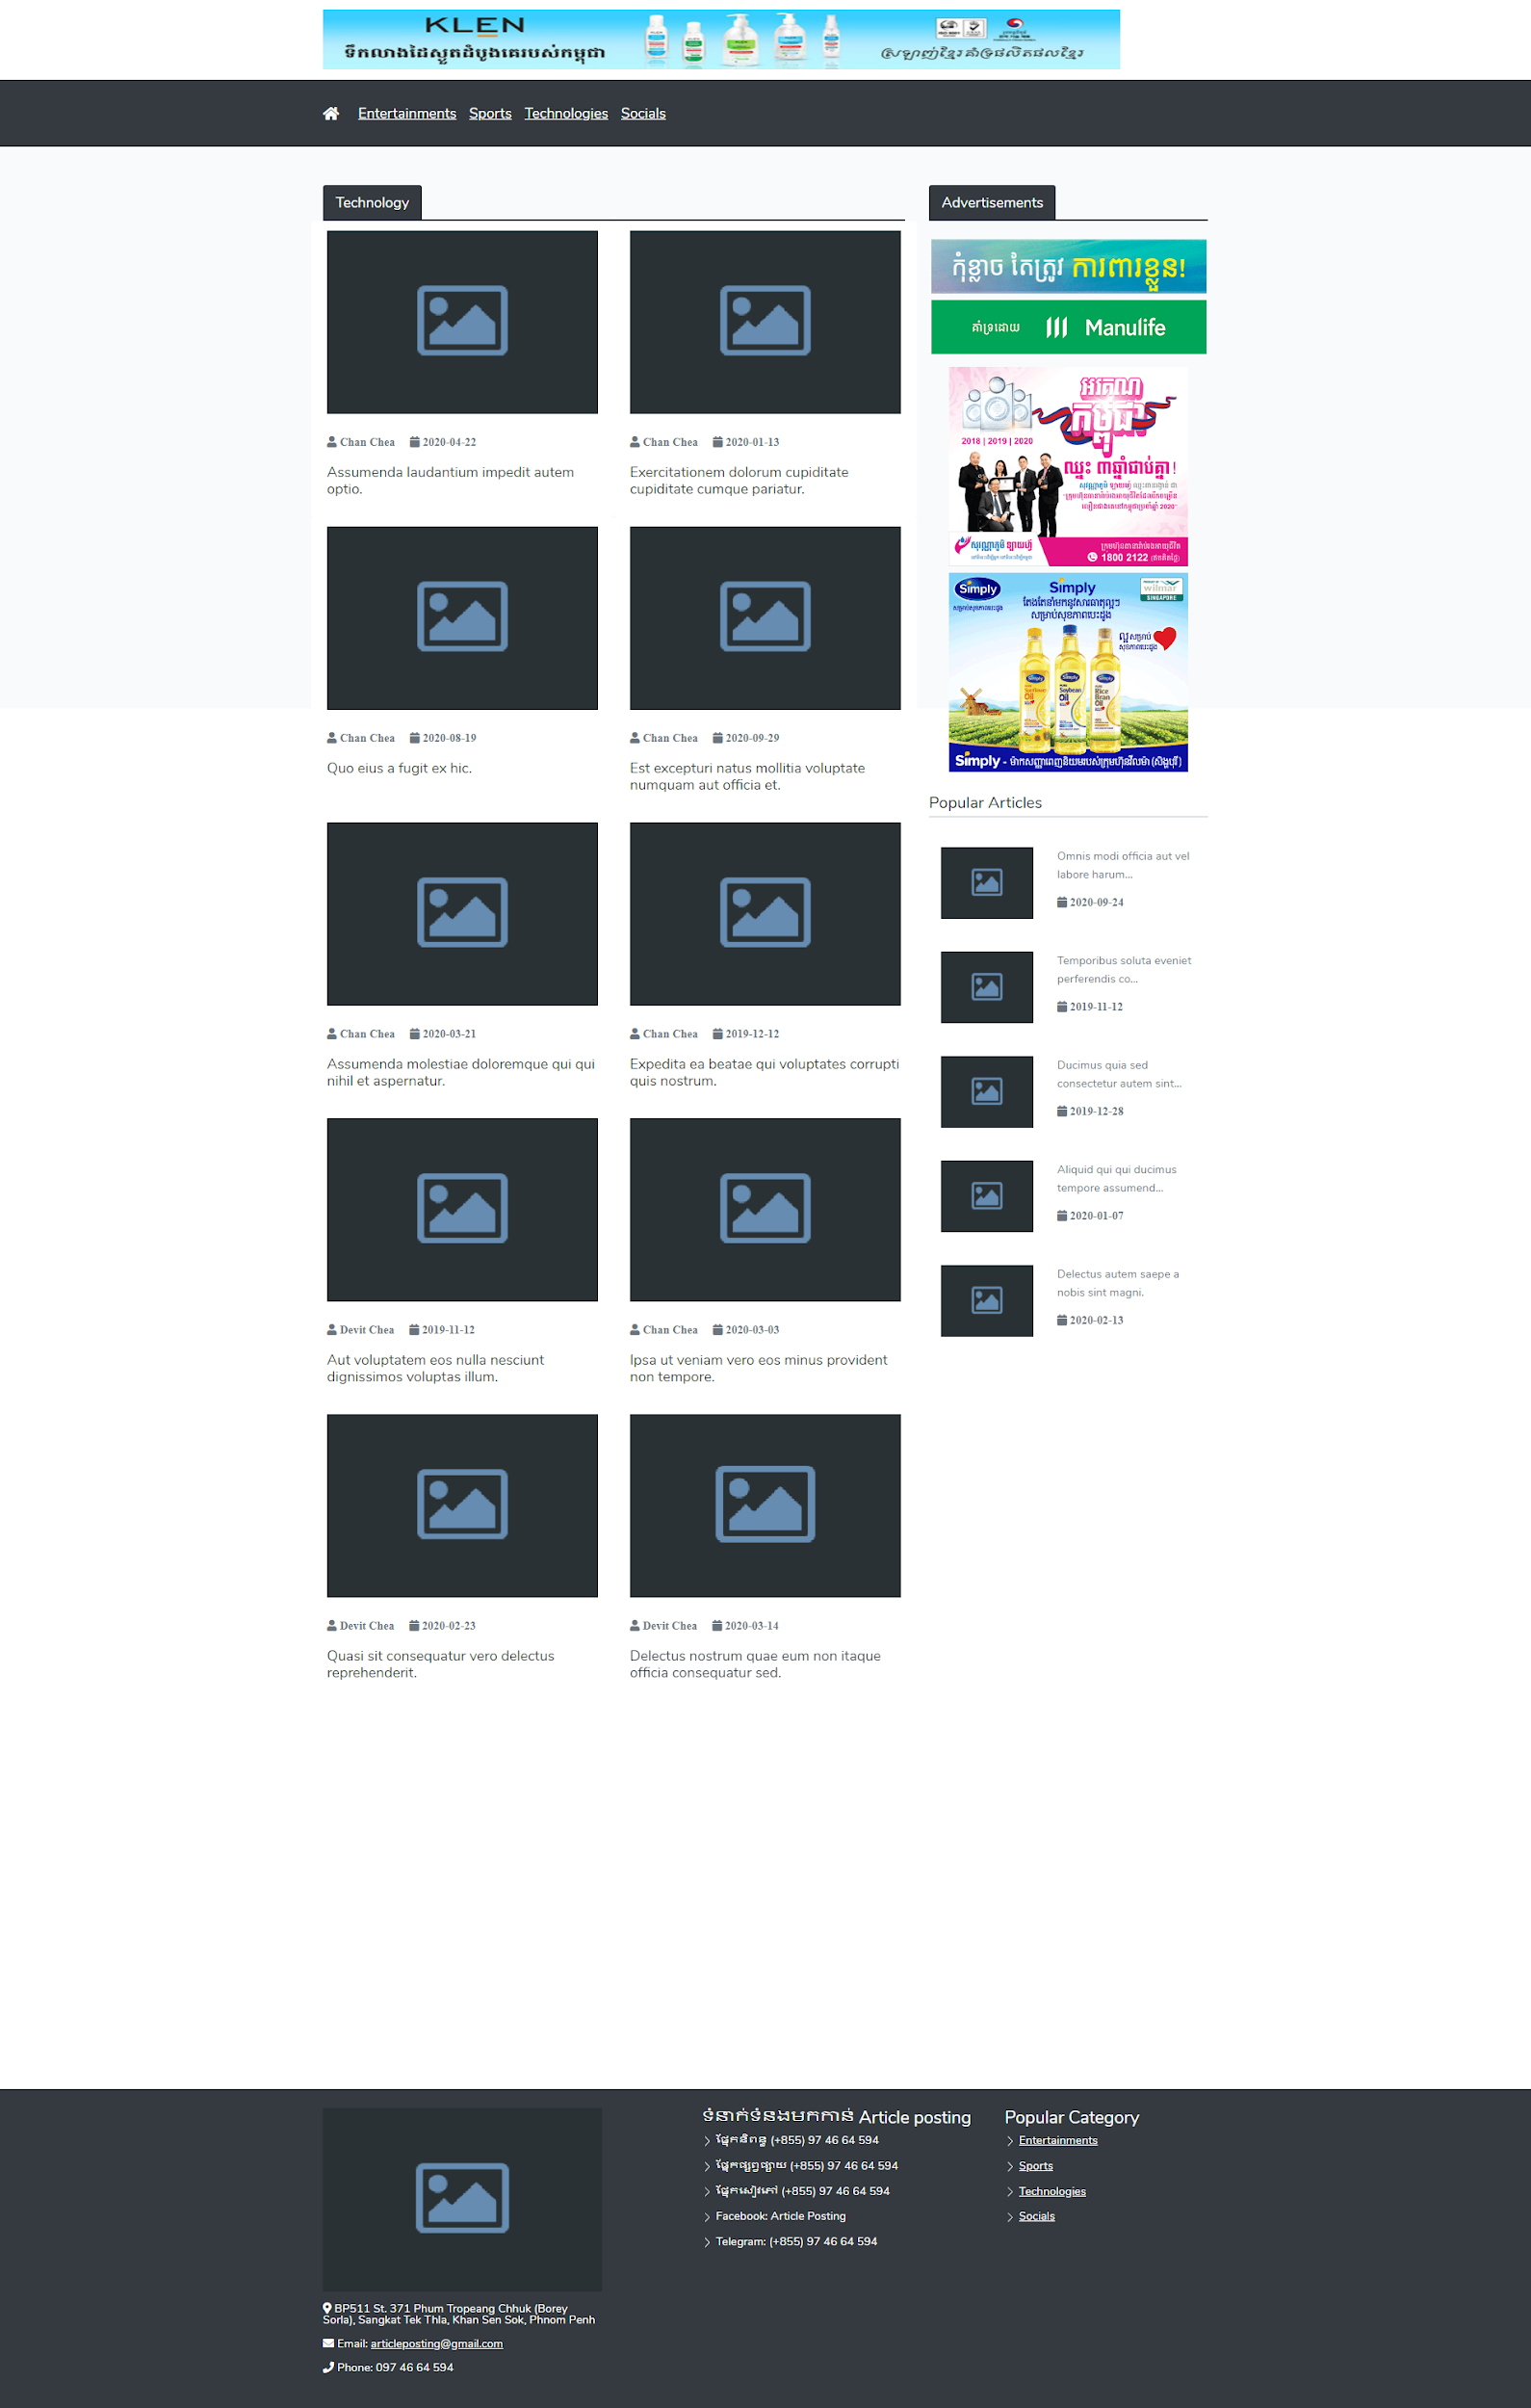

**8.3 Social media**

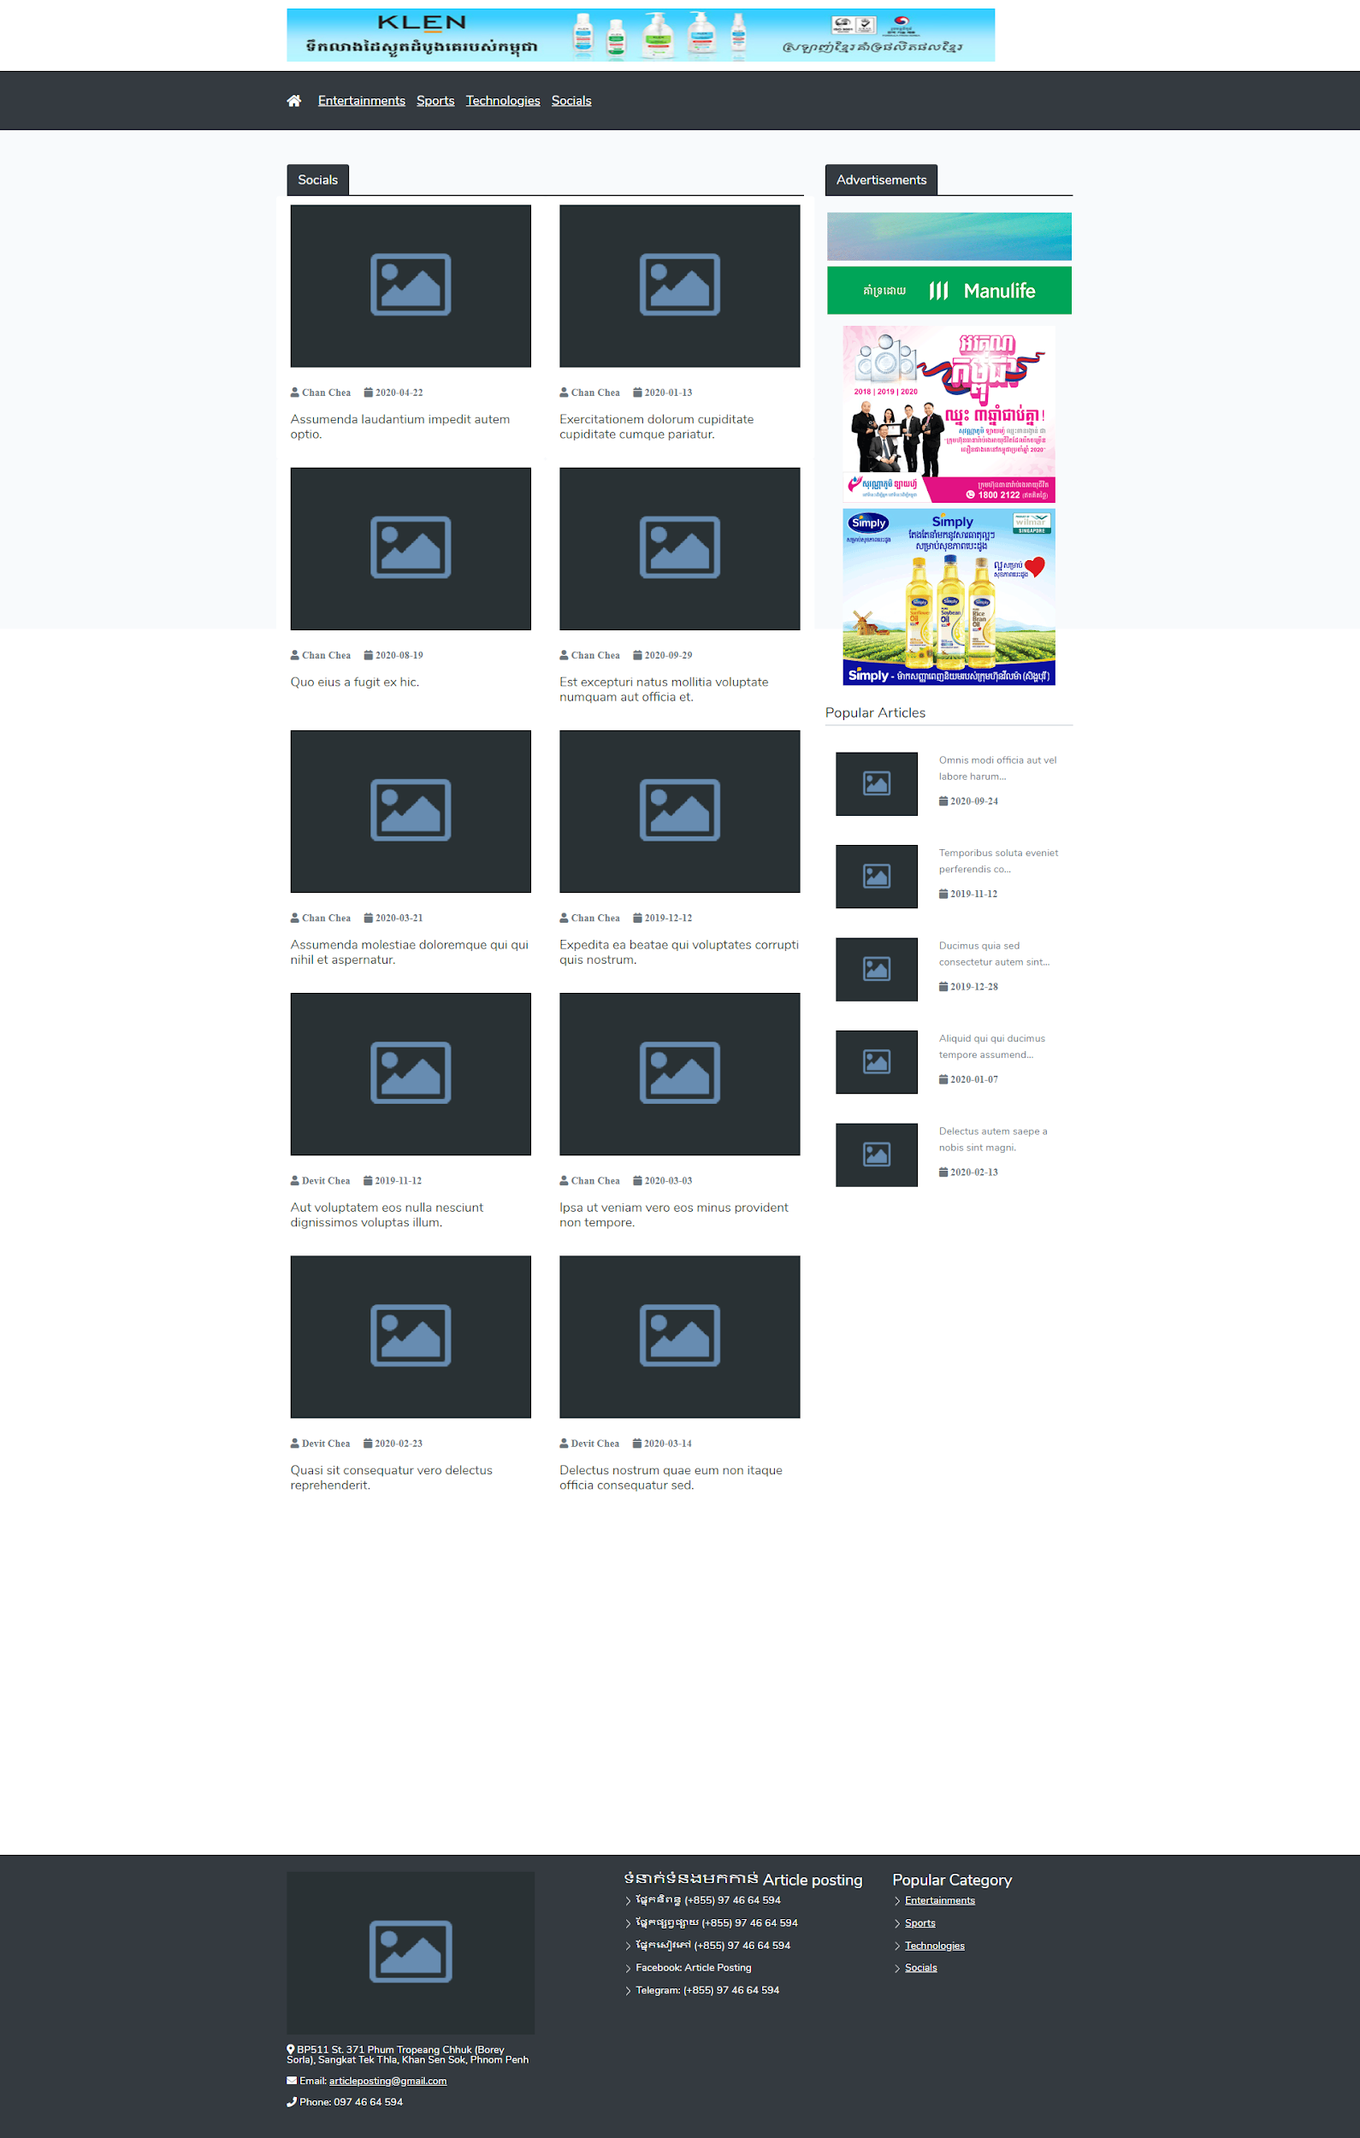

**8.4 Footer**

Normally a website footer is found at the bottom of your site pages. It typically includes important information such as a copyright notice, a disclaimer, or a few links to relevant resources. Footer show about location of company, menu category, and visitor and enquiry for advertisement.

**8.5 Amount Viewer**

All our articles in the website we can know the amount of the viewer. So we can know which part that interacts with people the most and which part that people don’t take time for view.

**8.6 Poster’s name**

Poster’s name is a part of our website that visitors or website controllers will know who is the poster of the article. It is a good part also that visitors can know the content poster.

1. **Category**

Web navigation refers to the possession of navigating a network information resource in the world wide web. Which is organized as hypertext or hypermedia. The user interface that is used to do so is called a web browser.

**9.1 Category List**

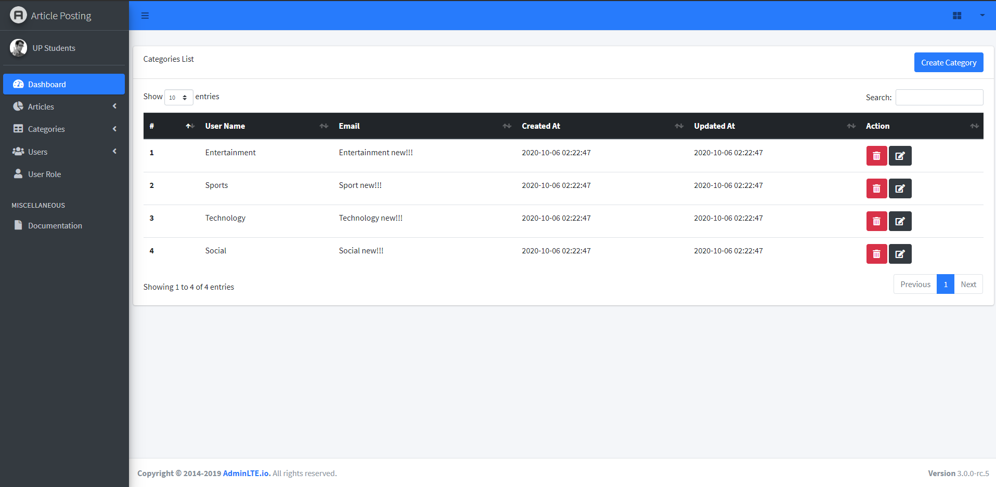

**9.2 Category edit**

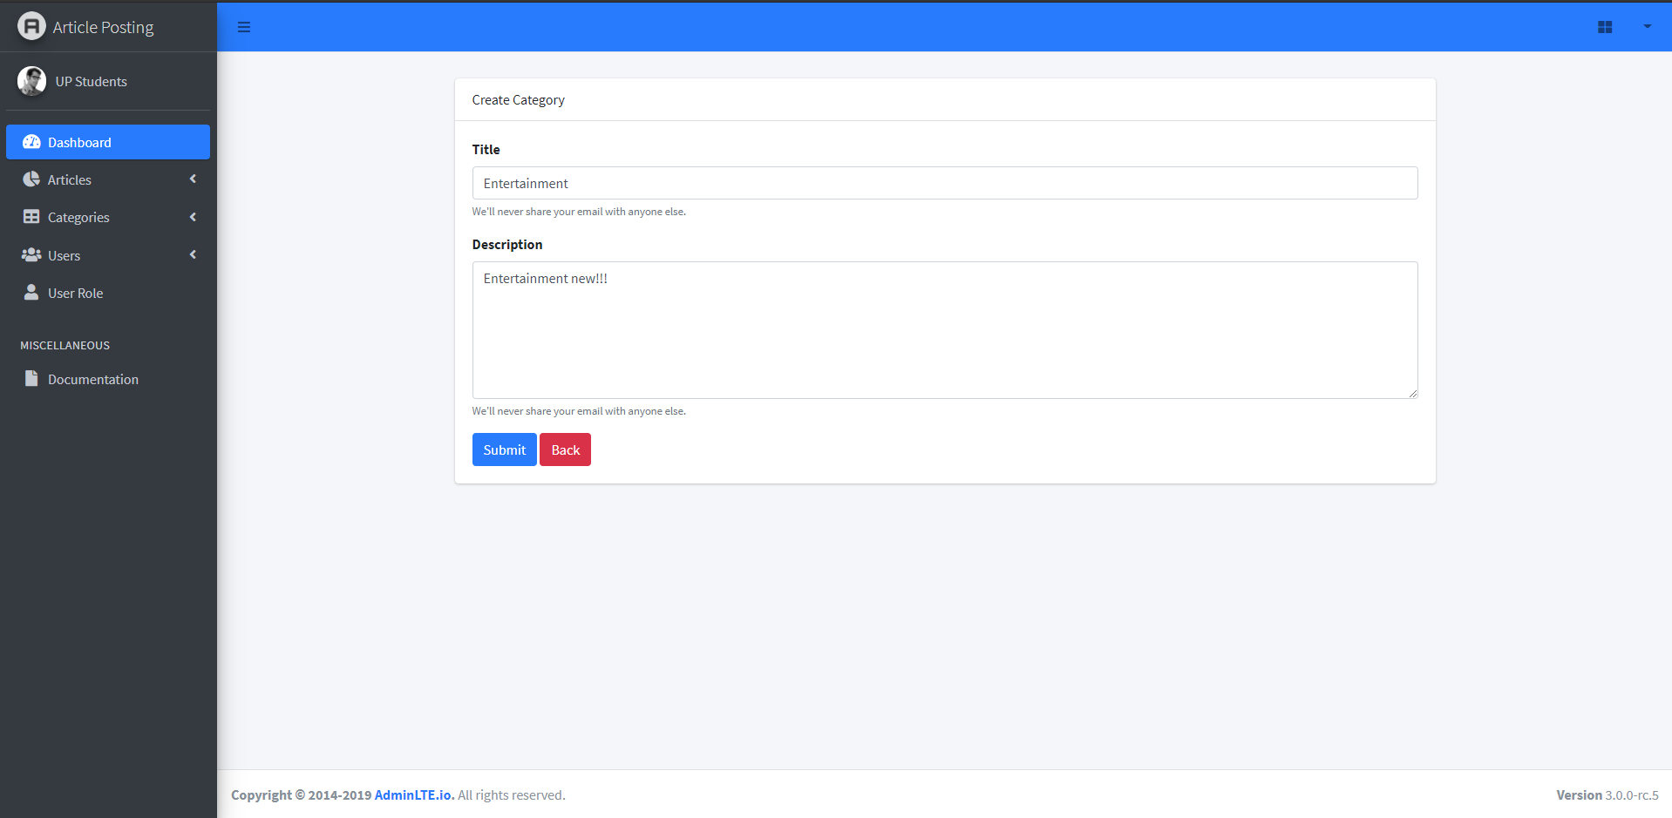

**9.3 Category delete**

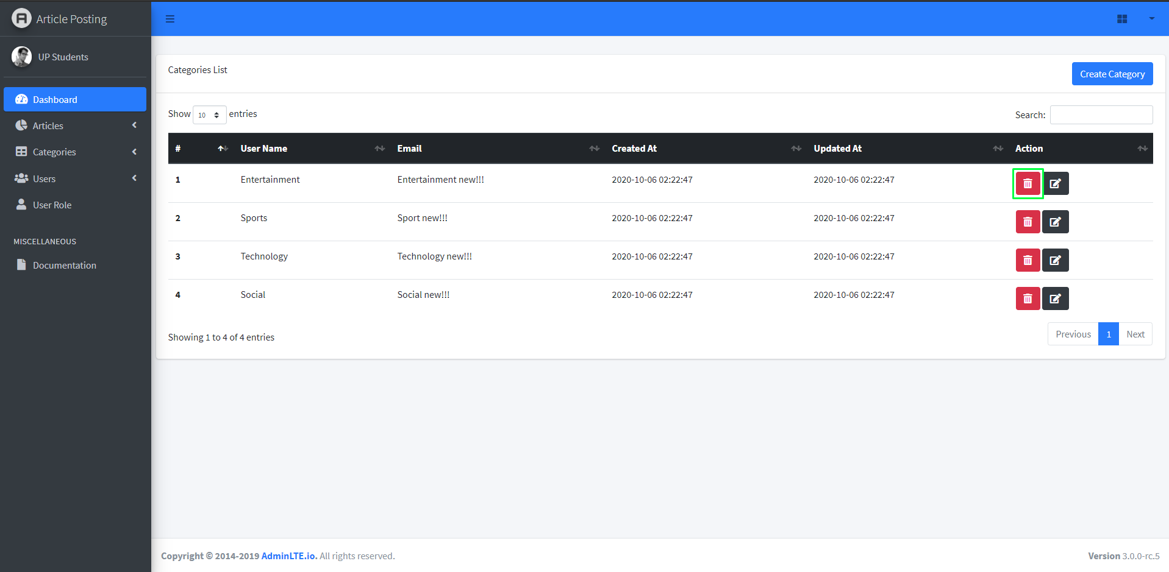

**9.4 Category add new**



1. **Home page**

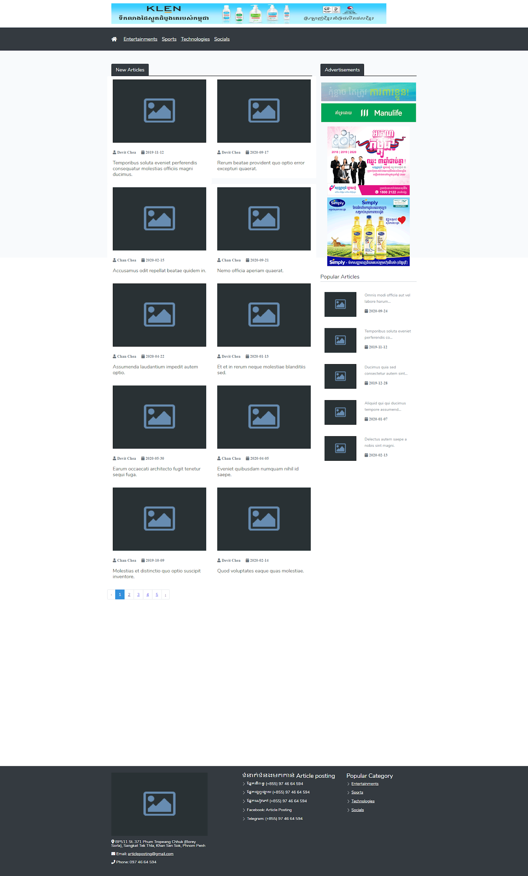

1. **Database Structure**

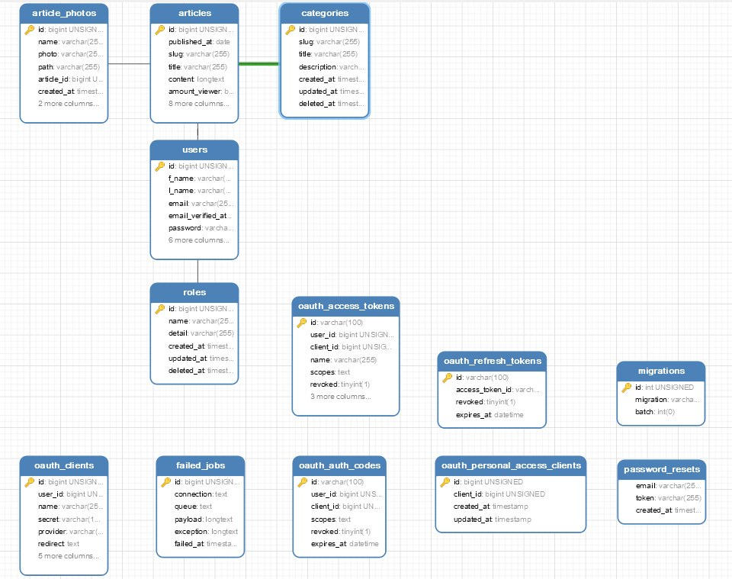

1. **Site map**

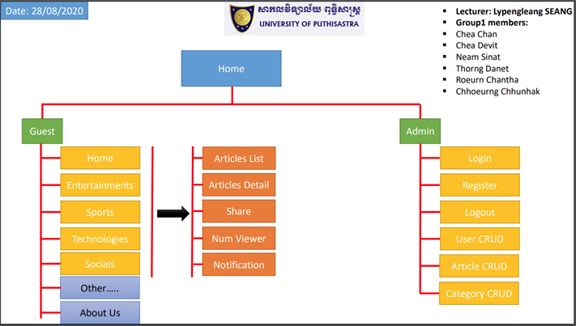

**IV. THE BEST 5 FEATURE IN THE SYSTEM**

1. CRUD Users
2. CRUD Article
3. CRUD Category
4. List the article with different categories
5. Article details

**Conclusion**

Article post is a piece of writing on a website with a front page with multiple links -- or content not displayed in reverse chronological order -- I would call an article. A “post” is a piece of writing on a blog, for example, Addressed to you which is delivered by a postal operator. There are different types of postal articles available. These include ordinary mail, registered mail, bulk mail, express mail etc.

As a conclusion, the proposed website will bring benefits to all users. Much of general knowledge can be helped for good communication technology. It aims to assist users in achieving their respective goals and objectives.

Reference: https://adminlte.io/docs/3.0/

**To people involved with this project**:

First of all, Thanks teacher for taking your valuable time to teach us. We really appreciate your advice. You always try hard to teach us even though we studied online for this Covid-19 period. We all have learnt a lot from you. Sometimes you were blaming us during study time. But in fact we knew you wanted us to study hard and put afford or commitment during study time.

Thanks to all team work that puts high commitment, help each other, follow up, and especially collaborate. It is a good experience that we have been working as a team together. One more thing it is a good time to learn from mistakes, error, coding, and communication. Proud to be your team.